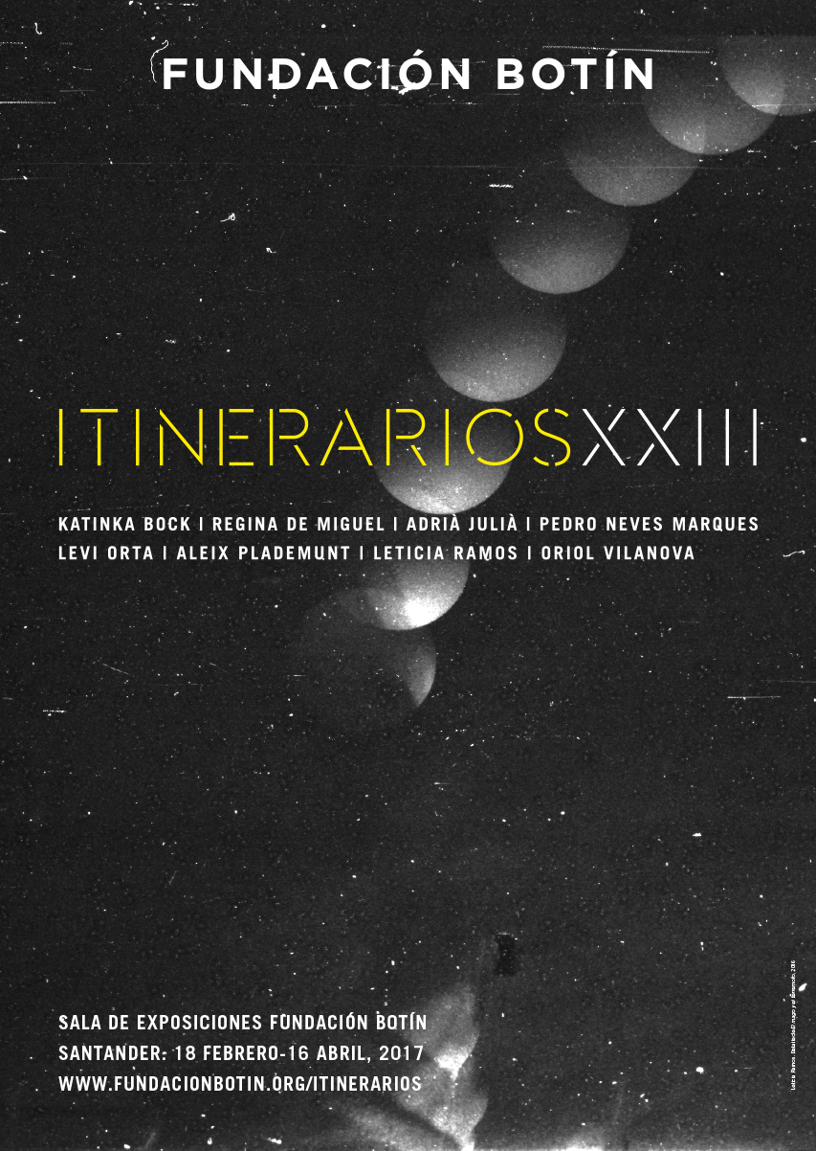
Fundación Botín presents the 23rd edition of “Itinerarios”, a survey of the work of a new generation of artists
- Serving as an annual showcase for the current state of the arts ever since 1994, this year the exhibition presents works by Katinka Bock, Regina de Miguel, Adrià Julià, Pedro Neves Marques, Levi Orta, Aleix Plademunt, Letícia Ramos and Oriol Vilanova.

- The artists employ contemporary media, particularly fixed and moving images, and share a common interest in exploring our surrounding environs and a concern for the relationship between man and nature.

Santander, 17 February 2017.- The Fundación Botín exhibition hall in Santander hosts, from 18 February through 16 April, the exhibition Itinerarios XXIII, an overview of the art of today, that acts as a showcase for the current state of the arts and a snapshot of the predominant trends both here in Spain and internationally.

The exhibition displays the result of the working process of eight artists: Katinka Bock (Frankfurt, 1976), Regina de Miguel (Malaga, 1977), Adrià Julià (Barcelona, 1974), Pedro Neves Marques (Lisbon, 1984), Levi Orta (Havana, 1984), Aleix Plademunt (Gerona, 1980), Letícia Ramos (Santo Antonio da Patrulha, Brazil, 1976) and Oriol Vilanova (Manresa, 1980). With this show, the jury, comprising artists and other professional artworld agents, wishes to highlight individual excellence as well as to promote some of the predominant trends in contemporary artistic creation.

Itinerarios XXIII provides an interesting overview of how a new generation of artists is working, and what seems to be core to their thinking and practice, showing us how certain preoccupations, and indeed methodologies, recur. The artists share an interest in exploring our surrounding environs, like scientists or archaeologists, and display the result of their processes in this exhibition as evidence of sorts. “In the work of this year’s roster of artists, there also seems to be specific concerns about humankind’s relationship to Nature”, argues the curator of the show, Benjamin Weil, who reminds us that over the past decade the notion of the anthropocene, an era wherein the global equilibrium of the planet is permanently affected by human activity, seems to have gained prevalence. He then went on to add that “some of the artists whose work is featured here seem to question the relevance of the art object outside of the urban environment, and perhaps how culture in general has contributed to the abstraction of Nature, which in turn may have led humankind to act so irresponsibly”.
The exhibition also allows us to appreciate how many of these artists are interested in contextualizing their work using custom-made devices or technology that are no longer used by the mainstream, something that perhaps enables them to dissociate their images from the ongoing flow we are exposed to, and to foster a different way of looking at them. The need to materialize their thinking process becomes core to many practicing artists today, as if, rather than representing the world, they seem to be inclined to demonstrate or perhaps re-orchestrate its materiality. And so, according to Weil, “interpretation or meaning is created by way of elaborating narratives that may altogether dismiss the importance of tangible elements. The materialization of thinking processes may therefore be an interesting answer to this era of “post truth” we may have entered”. And today, more than ever, humankind is faced with the fact there is not one single way to analyze and grasp our world, and that objectivity may turn out to be a construct; and this in turn produces a state of great confusion.
For their creations the artists, coming from Brazil, Cuba, Germany, Portugal and Spain, employ new media and tools, essentially fixed and moving images, making the most of the opportunity afforded by Fundación Botín to devise new projects or to develop projects already in progress, and in turn to stimulate our reflection.

Itinerarios XXIII - Artists
Katinka Bock (Frankfurt, 1976)
In her project Junimond [June Moon] the German artist explores the notion of disappearance, comparing and interpreting the basic parameters of sculpture with those of the history of mankind through the relationship between time and space: form, gravity, material properties, copy, unity, construction and destruction. At a point of unknown latitude and longitude between Sao Paulo and New York, and after having set sail from Arcachon Bay in France, sometime last year Katinka Bock sank four sculptural ceramic elements to the bottom of the ocean. The process of this action gave rise to new pieces that are later cast in bronze. The installation is composed of twelve ceramic and bronze cylinders and two projections. The films describe different actions, moments and “loci”: on one hand, we have the idea of natural space, by inserting the cultural object into nature while, on the other, we have the private, architectural space, by incorporating images of the artist at work in her studio. Finally, Bock also asks us to reflect on the Jurassic use she makes of technology, filming on Super 8, besides also using other archaic elements such as sailing and the use of ceramic, which, as she reminds us, is the oldest material created by man.

Regina de Miguel (Malaga, 1977)
Decepción is probably one of Regina de Miguel’s most obscure works to date, and possibly the one furthest removed from the idea of utopia, a recurrent concept in her practice, at least if we understand it in its science fiction guises. Science as a substratum of fiction has a long-standing tradition in the arts, but all fiction requires serious prior research, and this is what De Miguel did for many months before setting out towards the scenario of her project, developed in Argentina and Deception Island (Antarctica). Her work takes the form of an audiovisual essay combining various genres (personal diary, documentary, terror...) to demonstrate the research, underground prospections and simulation of spatial environments used by the CSIC Astrobiology Centre (Madrid), in collaboration with NASA, to study bacteria and extremophiles (microbial organisms able to survive in extreme conditions) in Deception Island. In addition, the artist proposes a feminist revision of various tropes of fiction and the foundational mythologies of the monstrous, as a kind of cartography of fictions of our social and corporal reality that engages with mythopoeia in order to propose models and chimeras that question the human paradigm.

Adrià Julià (Barcelona, 1974)
As part of a process of historical research on the nineteenth century and the phenomenology of technology, Julià travelled to Sao Paulo, Rio de Janeiro and the Amazon, following in the footsteps of Hercule Florence, the Franco-Brazilian inventor and pioneer of photography. The result was two works: firstly, Ejercicio para un paisaje sobreexpuesto (#1) [Exercise for an Over-Exposed Landscape (#1)], where he partially recreates the photographic process invented by Hercule Florence in 1833, using urine as a fixing agent. For 24 hours he exposed this paper in the Amazon jungle; hence the resulting overexposure, which hides all the information that has been fixed and yet remains concealed, as a metaphor of the contemporary condition; secondly, in Copia dinero copia (primer ensayo) [Copy Money Copy (First Test)], Julià proposes a work made using reproduction, falsification and printing techniques related with money, taking another of Hercule Florence’s inventions as a starting point, a type of paper designed for producing unforgeable banknotes, which was given the name “inimitable paper” and recalls a topographic image.

Pedro Neves Marques (Lisbon, 1984)
Environment and humanity are among the main concerns of Pedro Neves, whose works repeatedly focus on this issue, as well as exploring the roots of ecological thought through his work as an editor. For the artist, fiction is a vehicle for representing current thinking, and that is why Ywy, a androide [Ywy, the Android] is a short film whose action takes place in the present-future. It shows us a dialogue between Ywy, an indigenous android, and genetically modified maize plants in a field in a rural area of Mato Grosso do Sul, in Brazil. The woman and the plants speak about the rights of the body, infertility, labour and monoculture, although the human-spectators cannot hear the voices of the plants so that the dialogue becomes in fact an odd monologue. His second work on display in the exhibition, Aprender a viver com o inimigo [Learning to Live with the Enemy], was filmed in a documentary style and follows the production process of growing soya bean plants from Brazil to China.

Levi Orta (Havana, 1984)
Through his work, full of quotations from the media and the control mechanisms exercised by those in power, Levi Orta undertakes a direct critique through artistic action, engaging with the notion of political art in its most literal meaning. His contribution to Itinerarios XXIII is one of the projects made during the time he spent in the residency programme in Ashkal Alwan, Beirut. There he produced a series of works adding the geopolitical context of the Lebanon and the Near and Middle East to his broad-ranging references. In the installation Fuck the Proletariat, I want to be the official painter of the Gunther Family he gives an ironic account of the excesses of the global elite and the new relationships of power and control through the story of Gunther IV, the world’s richest dog, a German shepherd whose possessions include Madonna’s former home in Florida.

Aleix Plademunt (Gerona, 1980)
Driven by an obsession with finding the origin and documenting the universe, in his project Aleix Plademunt endeavours to revise, explore and extract new conclusions on ourselves and on our environment. Matter is an epic work that often goes way beyond the human scale and its space-time limitations. Begun in 2013 and still ongoing, it is a visual translation of the 118 elements discovered so far, the origin of the universe and the traces of the first civilisations and the material legacy they produced, as well as their projection into the future. In this exhibition Plademunt has chosen to use a selection of images to construct a photographic installation, taking the periodical table of the elements as a reference. Here the plot structure is similar to that of a constellation or a network, defined by the arrangement of its various units. This latest project he has undertaken is more of a revelation than a story, and in this sense it reminds us of a researcher’s “eureka” moment after years of work, that moment when all the unconnected elements seem to make sense when we stand back and look at the whole picture and when we can sense a whole from the particles.

Letícia Ramos (Santo Antonio da Patrulha, Brazil, 1976)
Letícia Ramos works in a hybrid area between science, history and fiction; and each of her projects is, in turn, an experiment. In Historia universal de los terremotos [Universal History of Earthquakes] the artist explores historical and scientific archives to research into two events that took place in Portugal: the great earthquake in Lisbon (1755) and the tsunami in the Algarve (1999), two catastrophic events which Ramos uses to produce a non-documentary narrative. The overall set of images in her work is part of a series of photographic experiments she undertook in Lisbon, made by microfilming a scale model of the called “gaiola pombalina”, an anti-seismic structure, and objects that come from the imaginary of magic and the occult. This gives rise to a crossover between science and craftsmanship, between knowledge and experimentation, in her various series. The work –which includes not only a series of photographs but also an artist’s book and a sculpture– is a fictional story based on an event which Ramos uses to weave an experience of her own, interweaving the natural with the mystical, the force of a geological phenomenon with the human construction of an imaginary governed by the irrational.

Oriol Vilanova (Manresa, 1980)
Oriol Vilanova collects postcards which he classifies in series and according to a colour scale. From this metacollection a number of series emerge, of which Todo y nada [All and Nothing] is the most significant and most numerous. Made up of 5747 postcards grouped into 27 different colours, the series consists of images of three-dimensional artefacts, preserved in museums and collections, objects whose meaning is accrued through being represented by the museum itself and through conflict with the real architecture in which the postcards are exhibited. For this exhibition the artist uses a slideshow presentation on five monitors with the postcards at a scale of 1:1, thereby highlighting new aspects, such as time and the fading of the object to invisibility on the monochrome background, as well as opening new doors to issues such as exhibition policies or the semantics of technology. In all, Vilanova has created some hundred series containing altogether a total of 30,000 postcards: a gigantic Borgesian archive, unfinished and in progress, and above all endless.

Fundación Botín Visual Arts Scholarships
The annual Itinerarios exhibition is the result of the work developed by Spanish and international artists during the period of their Fundación Botín Visual Arts Scholarships; and their artistic experimentation is documented in a catalogue as a form of displaying the various projects.

The Visual Arts Scholarships programme is conceived to foster training, research and the development of projects by Spanish and international artists. Since its inception in 1994, this initiative has helped to discover and support the careers of 184 artists, many of which now enjoy widespread recognition. For instance, at the ARCOmadrid art fair in 2016 there were 74 artists who were recipients of the foundation’s scholarships, and 19 of them had work on display in more than one booth. In addition, the two artists awarded with the 22nd ARCO-Community of Madrid Prize (David Bestuè and Rubén Grilo) are also former holders of Fundación Botín scholarships.

The eight artists in the Itinerarios XXIII exhibition were chosen by a jury comprising Mira Bernabéu, Alexandre Estrela, Carolina Grau, Álvaro Rodríguez Fominaya and Benjamin Weil. The selection was carried out from among the 676 entries received for the call for the 2015-2016 scholarships, of which over half came from Spain and the rest from Mexico, Argentina, Colombia, Italy, Germany and Portugal, among others.

The next call for applications for a Fundación Botín Visual Arts Scholarship will be announced in the month of February: bit.ly/becasartesplasticas

Exhibition activities
Admission free

The artists and their works
We invite the artists to introduce their work, thus fostering a dialogue with the public.
Dates: Wednesdays 1 & 22 March, and 5 April at 8:00 pm.

Adult sessions
A different way of learning and enjoying art through observation, reflection and dialogue, in a session with members of the Fundación Botín team.
Dates: Wednesdays 22 February, 15 March and 12 April at 8:00 pm.

Sunday art and family fun
These sessions are conceived to foster creativity in the family through games and art as a basic source of learning, growth and fun through activities for families with children from the ages of 6 to 12, accompanied by adults.
Dates: Sundays 19 February, 5 & 26 March, and 16 April. From 12:00 noon to 1:45 pm.

Group visits
Times to be arranged, by prior appointment. Tel: (+34) 942 226 072

For more information, contact María Cagigas on tel. (+34) 942 226 072 / 650 43 44 70 or at mcagigas@fundacionbotin.org

Images for the press

In the press section of the exhibition microsite (http://www.fundacionbotin.org/itinerarios) the following images can be downloaded in hi-res.

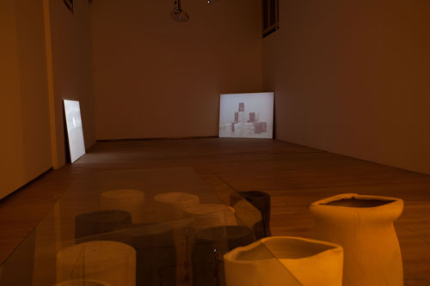
KATINKA BOCK
Junimond / June Moon, 2016
Bronze and ceramic
Detail of installation. Dimensions variable

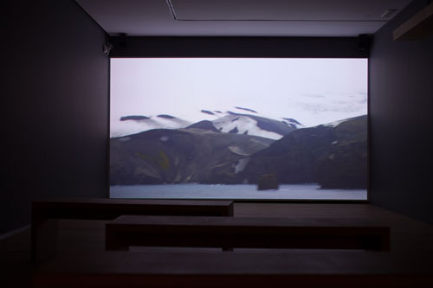
REGINA DE MIGUEL
Decepción, 2017
HD video, colour, sound. 28’19’

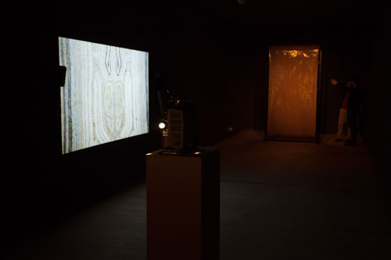
ADRIÀ JULIÀ
Copy Money Copy, (first test), 2017
Two-channel film and video installation
16mm film projector, looper, pedestal, video projector, minimac, amplifier, speakers, pedestal, 120 x 165 cm perspex structure
Dimensions variable

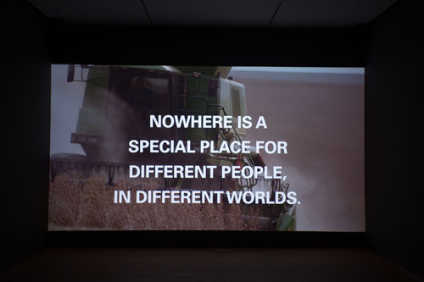
PEDRO NEVES MARQUES
Aprender a viver com o inimigo / Learning to live with the enemy, 2016
Video, colour, sound, 9’ 30’’

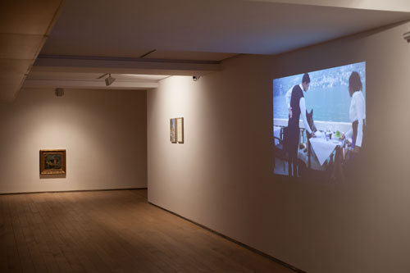
LEVI ORTA
Fuck the Proletariat, I want to be the official painter of the Gunther family, 2016
Photograph. Installation (detail)
Paint on wood, letter, photography and video
Dimensions variable

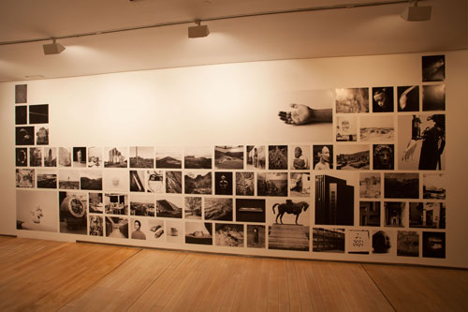
ALEIX PLADEMUNT
Matter, 2016
Photography. Mathematical expression of the standard model of elementary particles, which describes the basic structure of matter, sculpted at CERN (European Organization for Nuclear Research), Switzerland

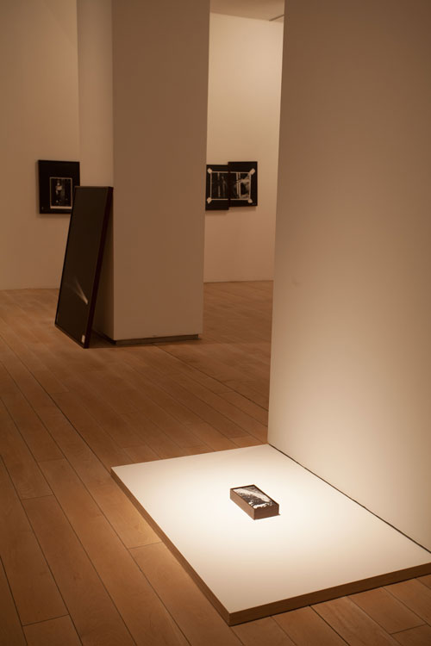
LETICIA RAMOS
Historia universal de los terremotos / Universal History of Earthquakes, 2016
Stroboscopic photography on microfilm
120 x 90 cm

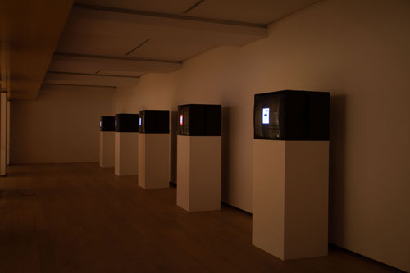
ORIOL VILANOVA
Todo y nada / All and nothing, 2017
Collection of postcards
Detail of installation at M Museum Leuven, Belgium. Photos: Dirk Pauwels

